# Data Visualisation using AI Assignment

Objective-01 🡪 To Generate a histogram using any library to visualize the distribution of salaries among employees in the dataset.

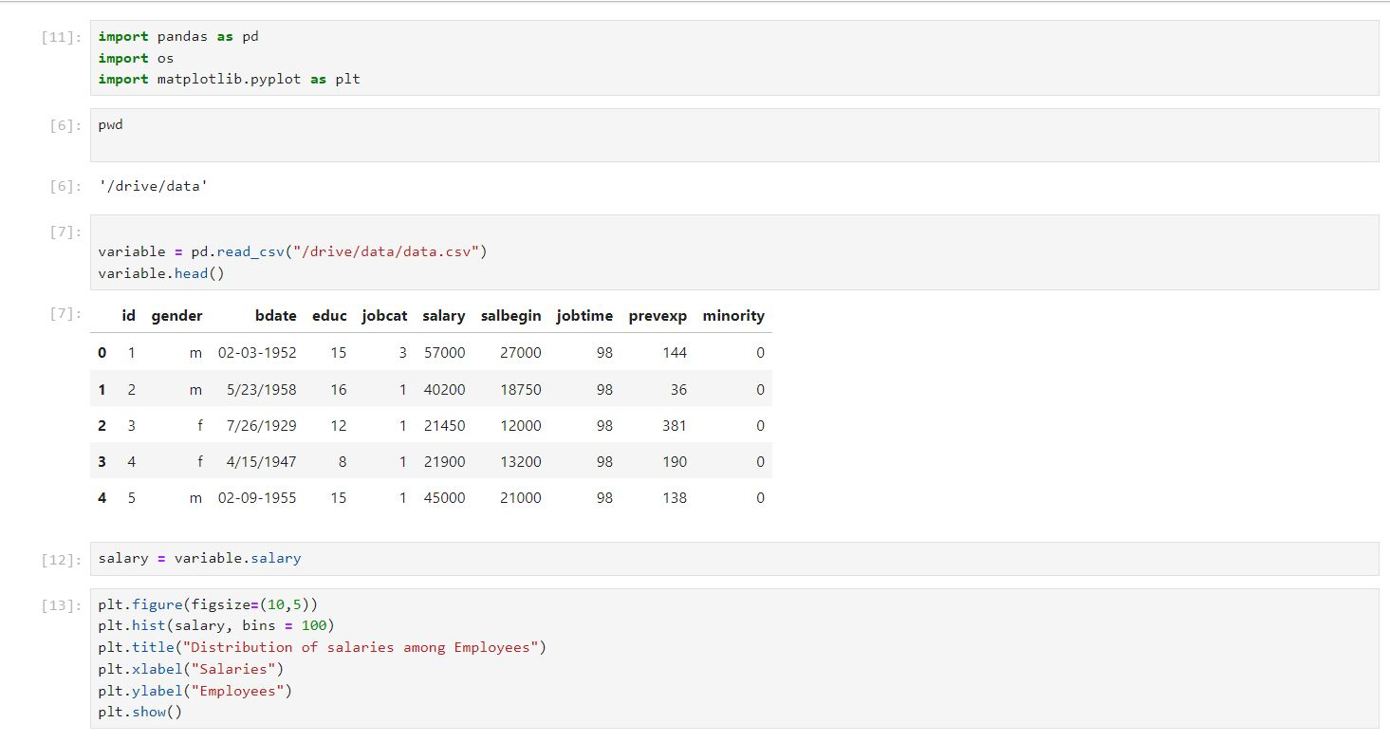

## 

## Objective-02🡪 Generate a bar plot to compare the average salary of male and female employees using any library.

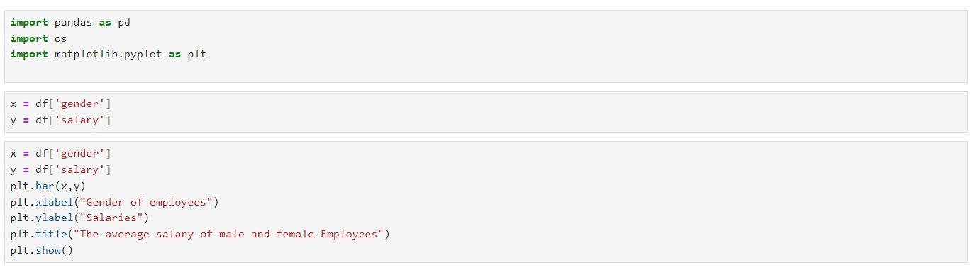

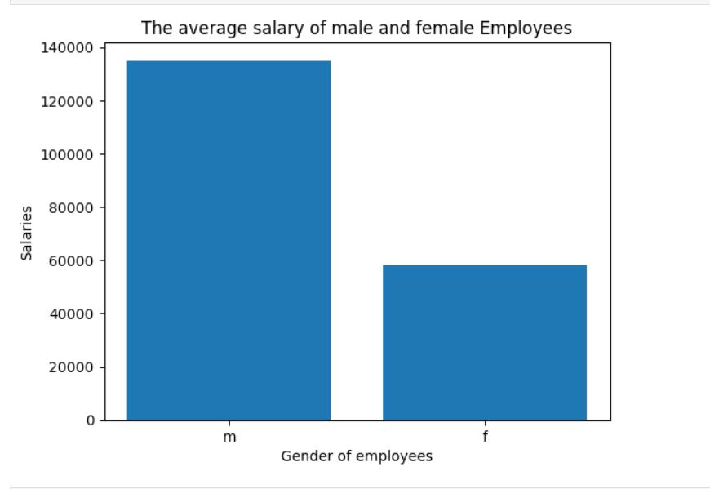

## Objectice-03🡪Create a scatter plot using any library to illustrate the relationship between previous work experience (prevexp) and the current salary of employees.

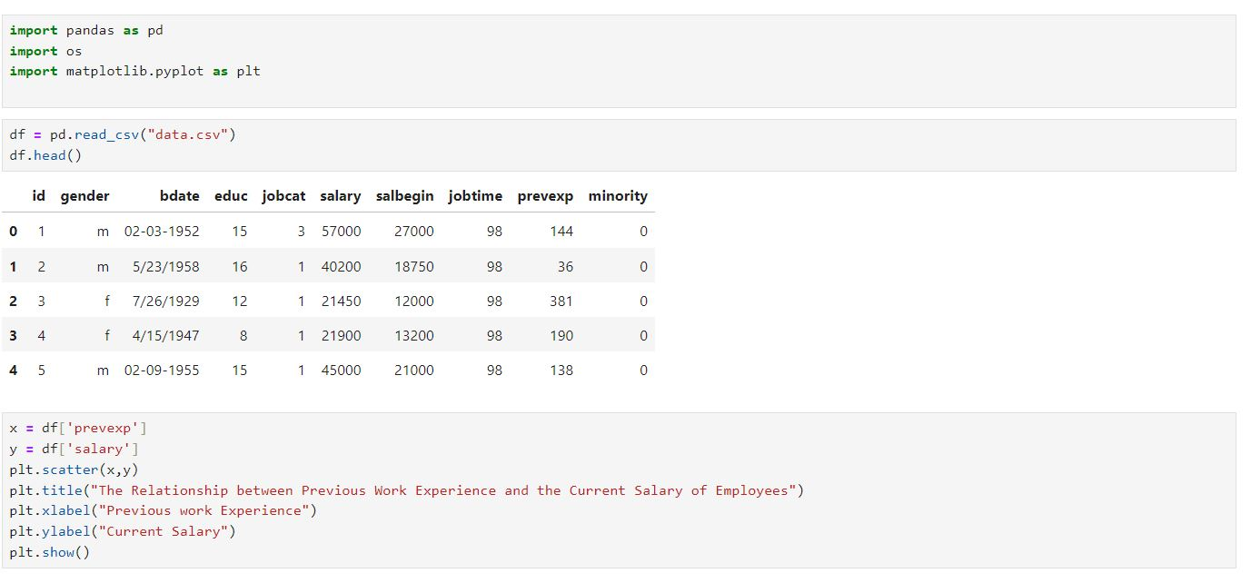

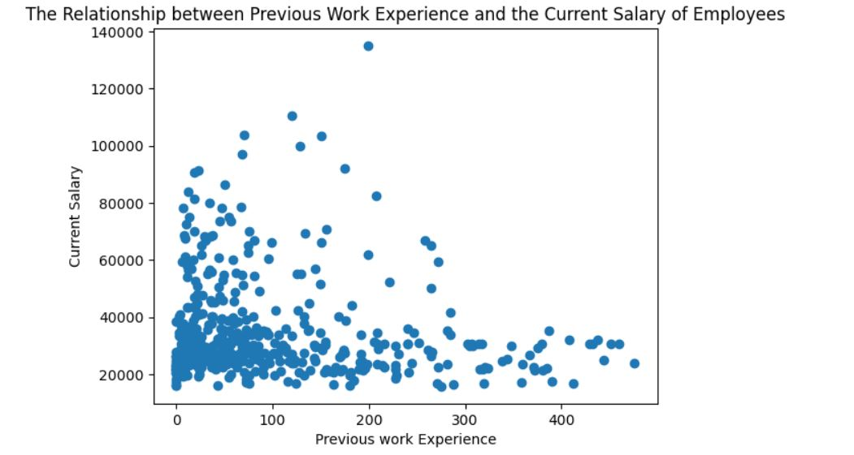

Objective-04🡪Generate a pie chart to visualize the distribution of educational backgrounds among employees.

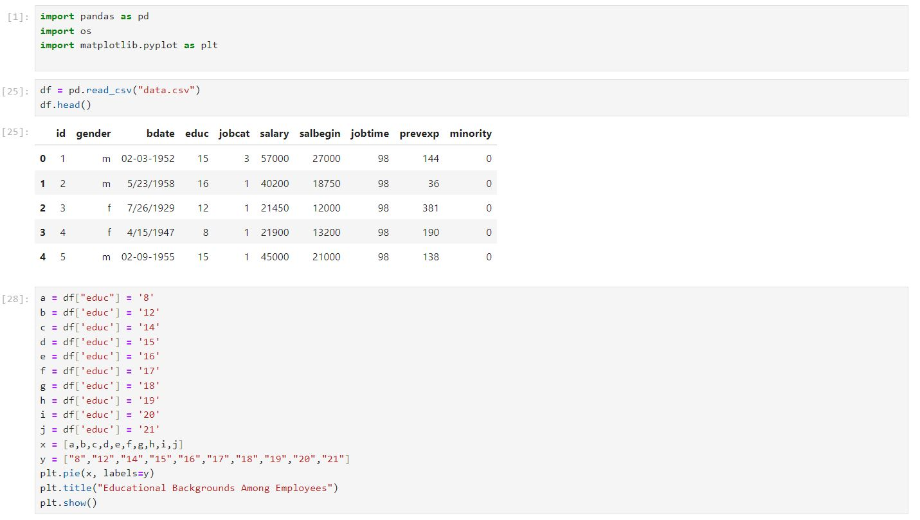

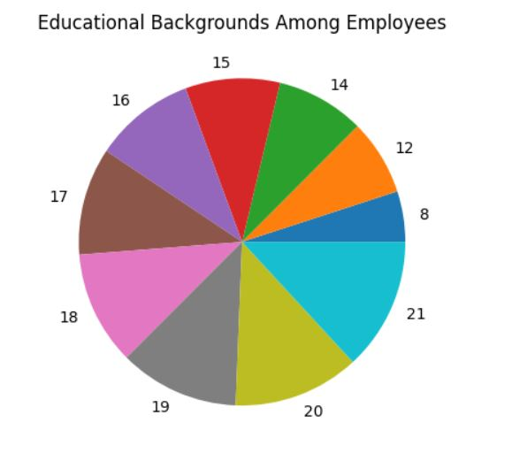

Objective-05—>Use any AI library such as sweetviz or dtale to generate the summary of the data.

## 

